Assignment 6
sai
February 20, 2026

Java Ride Sharing code output
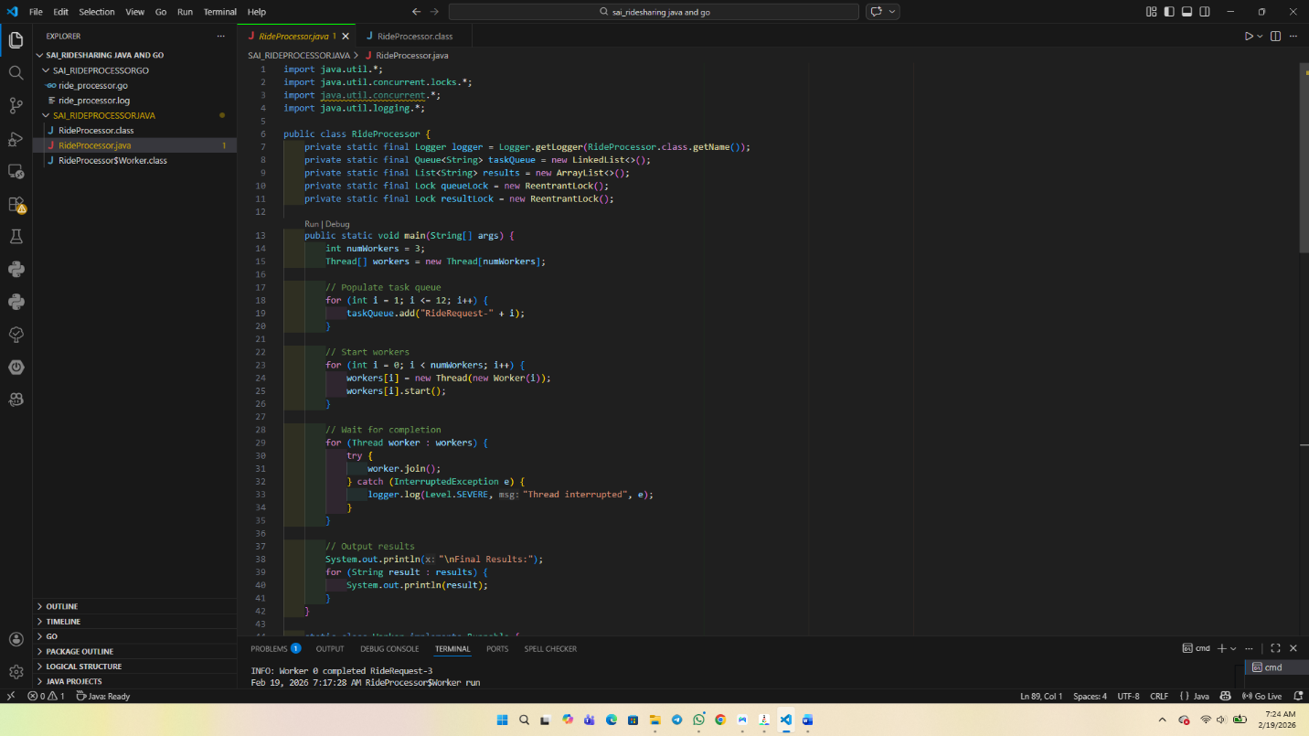
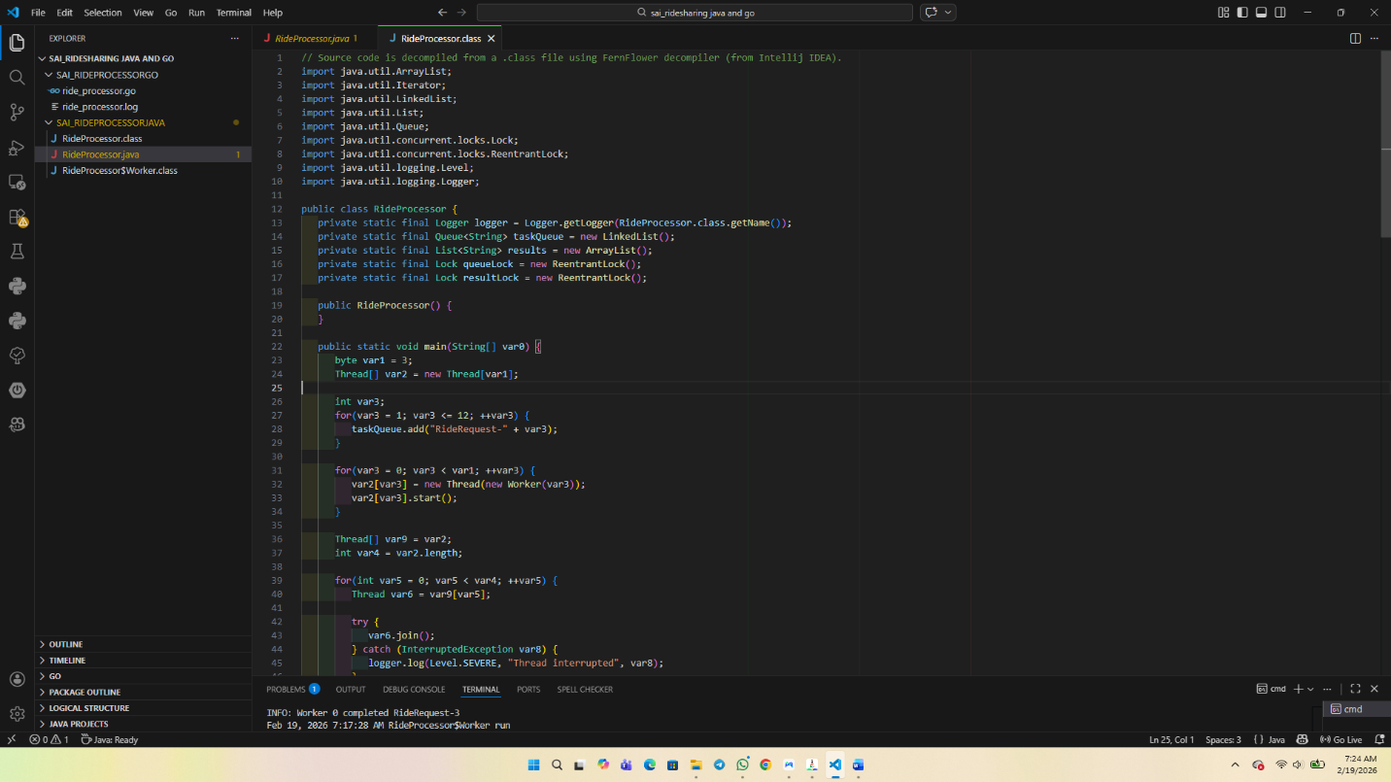
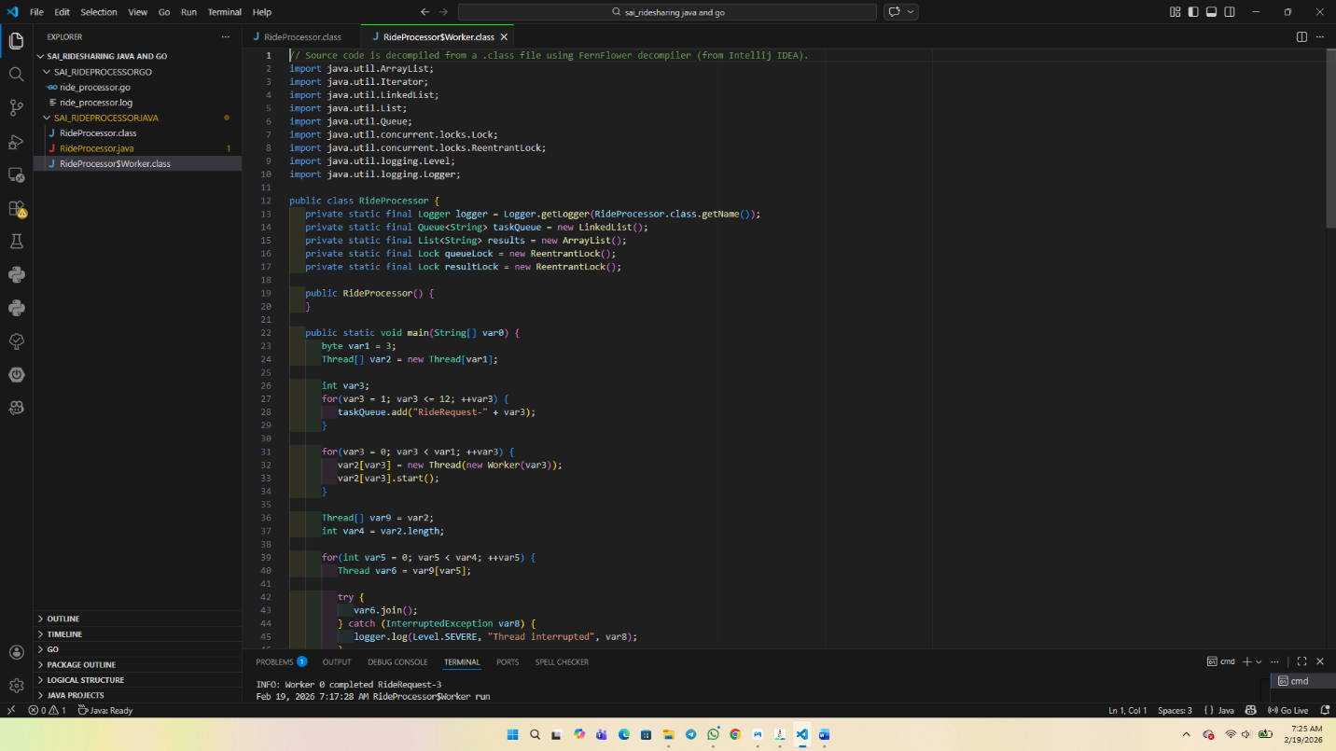
Java Ride Sharing output
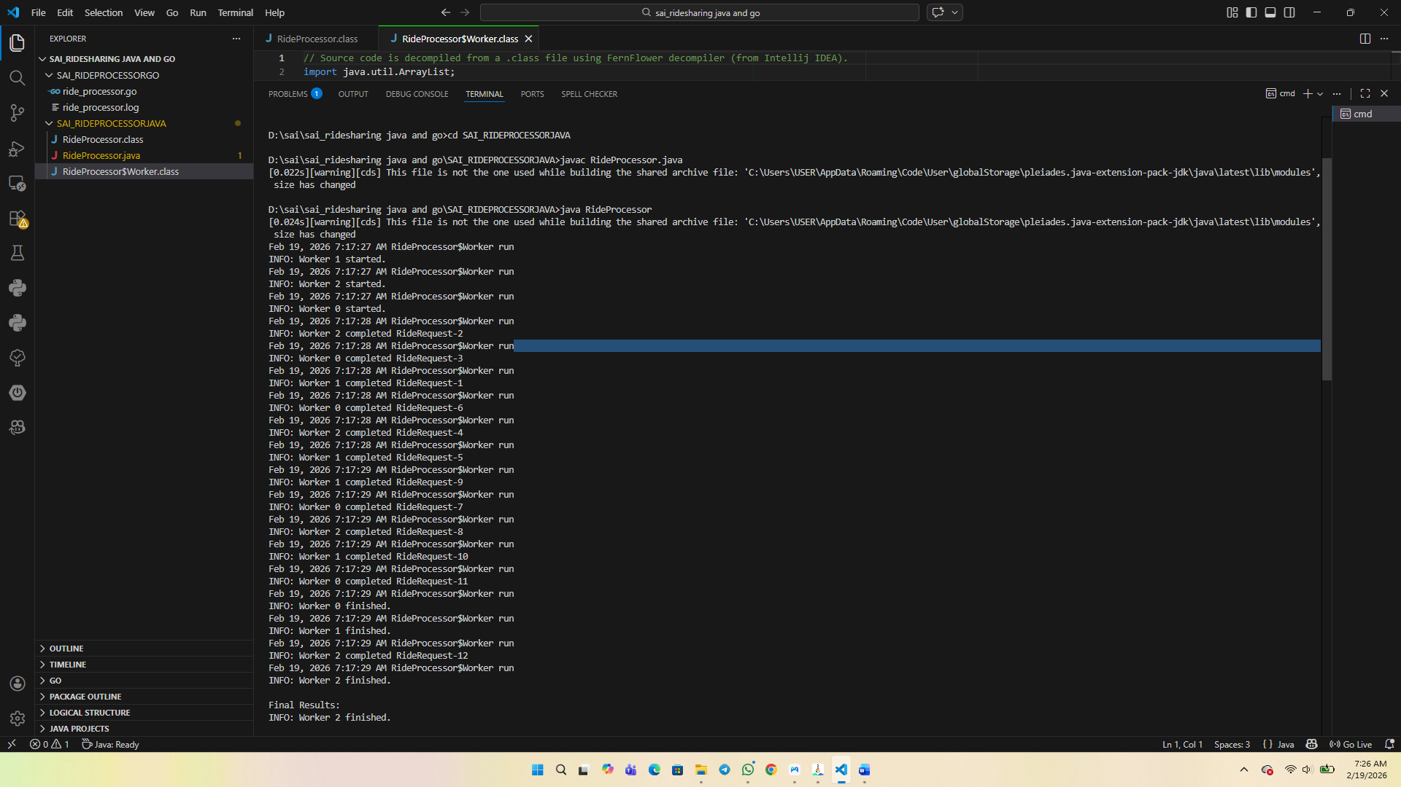
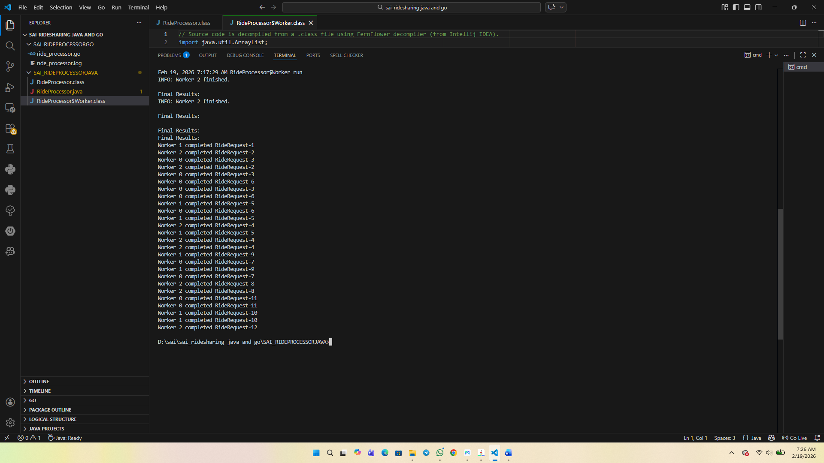
Go Ride Sharing system code output
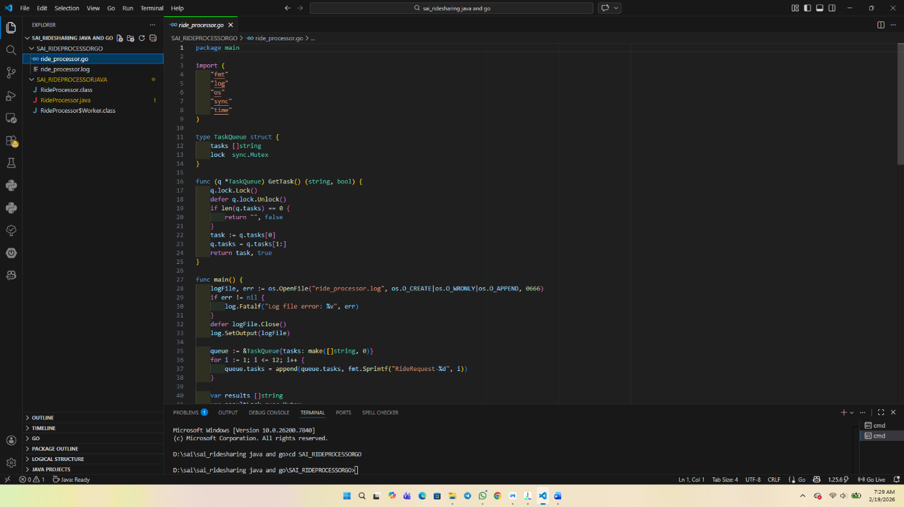
GO Ride Sharing System output
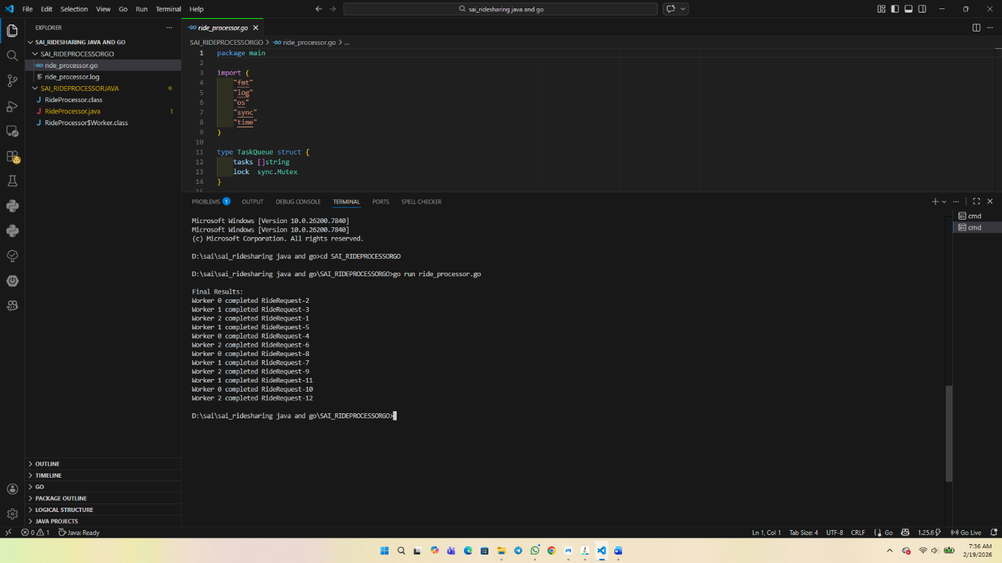
Report
Java and Go Ride Processing Systems Concurrency and Error Handling.
Introduction
In this report, two applications of a ride processing system written in both Java and Go are evaluated. Both models reproduce the environment where several workers are simultaneously retrieving the ride requests in a queue of requests, processing them, and storing the results in a shared collection. This analysis aims at discussing how to use concurrency techniques and how to handle errors in the two languages properly. The report also evaluates the differences between the concurrency model and execution management of Java and Go.
Java Techniques in Concurrency.
The Java implementation has employed the use of several Thread objects so as to execute and be executed at the same time. The task queue, result list, and other shared resources are guarded with the help of the ReentrantLock, so that they are mutually excluded. This shuns the problem of race conditions by permitting at a given time only one thread to enter the critical sections. Finally blocks release locks to ensure that they are properly unlocked despite the occurrence of an exception which will lessen the chances of deadlocks.
Thread coordination, through the start and join methods, is used to control them. The join method is used to make the main thread wait till all the worker threads are fully executed before final results are printed. This is an indication of proper synchronization and lifecycle management (Oracle, 2024).
Java has created exception handling which is done through try-catch blocks. Potential InterruptedException and other runtime exceptions are processed in each worker thread without aborting the whole program. The logging is done with the help of the framework of the Java.util.logging, which is used to document worker activity, and any errors. This exception management model is very reliable and resilient.
Go in the Parallel Changing Style.
Go implementation is based on goroutines which are small threads handled by Go runtime. Unlike operating system threads, goroutines can be effectively utilized and deliver much better concurrent performance with much reduced overhead. The shared resources, including task queue and result slice, are guarded by a sync.Mutex to have concurrent access.
A sync.WaitGroup is used to synchronize the completion of goroutines in the sense that it blocks the main function until all workers have completed their tasks. This eases the synchronization process over hand threading in Java. The concurrency logic is also represented by structured elements, which enhance modularity and minimize the complexity (Go Documentation, 2024).
Go has a defined structure in error management. Rather than exceptions, the error is returned as a value and checked with the help of conditional statements (if err!= nil). The output is logged to a separate file in order to have a continuous record of execution. The defer statement makes sure that even in case of error, the resources, e.g. file handles are released properly. This is a direct and simple mistake management, which is in line with the design philosophy of Go (Donovan and Kernighan, 2023).
Concurrency Models Comparison.
The Java concurrency is based on operating system threads that are handled by the Java Virtual machine (JVM). It contains a sophisticated synchronization implementation such as ReentrantLock, synchronized blocks and executor frameworks. The model provides a better level of control over thread behaviour and execution flow but can be more resource consuming (Oracle, 2024).
Comparatively, the Go concurrency model focuses on goroutines that the Go runtime scheduler manages. Goroutines are simple and scaleable and with few overheads, we can have thousands of running tasks. There is synchronization via mutexes or channels, and coordination via WaitGroup minimizes boilerplate (Go Documentation, 2024).
On concluding, Java stresses the sharp thread control and strict synchronization whereas Go is more simple, scalable, and provides in-built primitives of concurrency. The two implementations behave in a manner that properly applies the concurrency techniques and appropriate error handling strategies and prove that parallel processing is safe and efficient.
References
Donovan, A. A., & Kernighan, B. W. (2023). The Go programming language (Updated ed.). Addison-Wesley.
Go Documentation. (2024). Concurrency in Go. https://go.dev/doc/
Oracle. (2024). Java platform, standard edition documentation: Concurrency. https://docs.oracle.com/en/java/

